- Design Project Case Study
This appendix contains a highly condensed case study of a capstone design project that was developed by a team of students utilizing the principles of this textbook. The complete project report can be downloaded from the McGraw-Hill website for the textbook, along with a number of other case studies.

The Visual Aid
Ryan Andrus, Luis Catoni, Carl Schnur, and Freddy Chiu
A Senior Project Report Submitted to the Faculty of
Electrical, Computer, and Software Engineering
Penn State Erie, The Behrend College
April 2006
- Problem Statement
  - Need
Visually impaired people often have mobility difficulties due to limited spatial sensing—determining where objects are. Although many receive education in mobility techniques and enhance other senses to create better awareness of surroundings, there is a need for a more accurate spatial description. For example, according to the Vision and Blindness Resources Center in Erie, visually impaired people are able to detect walls due to different sounds in the environment. However, a tree branch, stairs, or a street sign may be undetected. Due to objects that cannot be perceived by sensorial means, many devices have been designed to detect objects in the path of a visually impaired individual. Common mobility resources are guide dogs, canes, and electronic travel aid (ETA) devices. Unfortunately, these resources are either limited or too expensive. There is a need for a device to provide an effective way to detect objects and be cost-efficient.
  - Objective
The goal is to design and implement a digital system that give visually impaired an enhanced awareness of their surroundings. The system will detect objects and provide real-time feedback to the user according to the size, position, and distance of the object.
1.3 Research Survey
For over 30 years, people have been attempting to invent an electronic device to help the blind navigate. According to the American Foundation for the Blind [1], there are about 10 million blind and visually impaired individuals in the United States.
According to Seeing Eye [2], an organization committed to train dogs for the blind, around 1% of the visually impaired use guide dogs. Many do not choose this option due to allergies, facilities needed for dog care, training for both the dog and the individual and finally, personal preference. The rest of the blind community relies on canes, electronic travel aids (ETA), and their perceptual senses.
The cane is the most popular tool for object detection for the blind. Nevertheless, this tool is limited as it is difficult to locate objects that are not at the ground level. For example a tree branch will go undetected by an individual using a cane. However, there are ETAs designed to overcome this problem. The most popular ETA is a cane that contains built-in laser sensors for object detection called the LaserCane [3]. This system integrates laser sensors near the handle of the cane and detects objects in 3 different angles. This system provides feedback to the user by sound or by vibrations produced on the side of the cane sensed by touch. Although this design offers the blind more resources to identify possible objects in front, it has limited feedback. For instance, the laser sensors fire a beam so narrow that users must be master the movements of the cane in order to detect objects accurately. Moreover, this device costs around $2,500, which places an attainability issue for many visually impaired.
According to the director of the Vision and Blindness Resources Center in Erie—whom was interviewed as part of the project’s research—the visually impaired are trained to orient themselves and navigate using their senses. However, major difficulties arise from objects that cannot be sensed. Therefore, basic mobility needs of visually impaired consist of object detection with a range of approximately 1 meter from the body, as a minimum, and 2 feet wide—the width of the body. Such objects may include desks, chairs, steps, and tree branches. In an interview with a visually impaired student on campus who uses a guide dog said that surface differences of approximately 2 in. should be considered dangerous, and must be detected by the ETA system.
Based on the needs and common hazards that the visually impaired encounter, key characteristics must be carefully addressed when designing an ETA device. First, the sensing system must be able to detect objects of varied sizes and cover a wide range for ease of detection. Second, GPS and compasses may be used for orientation. Third, an intuitive feedback system must be used. Such a system cannot employ sound as this interferes with the hearing of the visually impaired. Finally, the system must be affordable. Research shows that no single device meets all these needs and has been widely accepted by the blind community.
  - User Needs and Objective Tree
The team interviewed a number of sources to identify the objectives in the tree below.
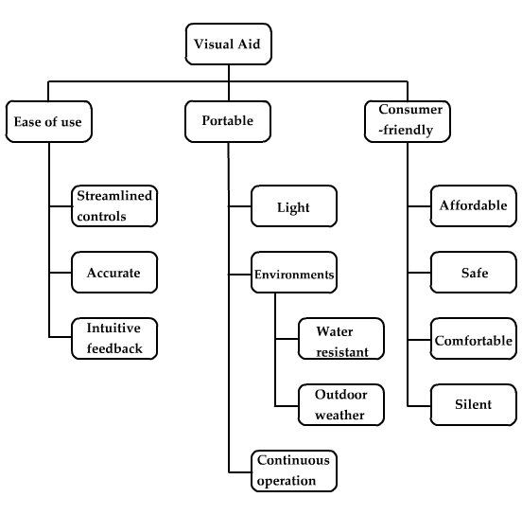
Figure 1 – The needs and objective tree.
Weightings of the objectives were determined using the pairwise comparison method for all levels of the objective tree. The results for the highest level of the tree are portability (0.20), consumer-friendly (0.30), and ease-of-use (0.50). This result arises from the need that the ETA must be easy to use because an overly complex interface would create a high barrier to using and then accepting the device. Along the same lines the device should create a minimum amount of disturbance to the user’s environment. Finally, while important portability is the least of the three concerns.
- The Requirements Specification
Table 1 - Requirements Specification for the Visual Aid.
Marketing Requirements | Engineering Requirements | Justification
1, 2, 10, 13 | - The system’s total weight will not exceed 5 lbs. | Based on the weight of other portable devices, such as laptops, and the weight of book bags.
7, 8, 13 | - The system will have a single control to turn it on/off. | Based on the user’s need for the system to be as simple and intuitive as possible and the average person’s familiarity with technology.
5, 13 | - The system will operate on full charge for at least 3 hours. | Based on the expected daily use by considering average daily walking time (2.1 miles at 3.3MPH≈38 minutes/day) by a factor of approximately 5.
6 | - The system should not exceed $600. | Based on the cost of competing products [6], such as the LaserCane.
11 | - Uneven surfaces (steps, rocks) of at least ±1.25in high will be detected at a distance of at least 3 ft away from the user. | Based on the size of possible hazards, such as rocks, bottles, sign posts, stairs, etc.
11, 14 | - The system will detect objects that are at least 1in wide and 2in high at a distance of at least 3 ft from the user and as far as 7 ft in an area 2 ft wide, and provide sensory feedback. Also, the system should detect street signs and posts. | Based on the user’s need to timely and intuitively be notified of hazards.
12 | - The system should not produce noise exceeding 40db. | Based on comparisons of sound levels at an office, bedroom and living room environment [7].
3 | - The system will be built with components that can operate in temperatures ranging from 0˚F to 120˚F. | Based on the expected range of temperatures the user might operate the device in.
3, 4, 9 | - The system components will be enclosed to be water-resistant. | Based on outdoor environments and its conditions (snow, rain, humidity) the user might face and the need for the user to be protected from electrical shock.
14 | - The system will refresh its output according to sensor readings 5 times per second. | Based on the average reaction time of humans (0.33 seconds) [8].
Marketing Requirements
1) Portability, 2) Weight, 3) Operable Environments, 4) Water Resistant,5)Operation Time, 6) Cost, 7) Ease of use, 8) Streamlined Controls, 9) Safety, 10) Comfortable, 11) Accurate, 12) Noise Level, 13) Consumer-Friendly, 14) Intuitive Feedback

- The Design
The Visual Aid device has three major physical components: 1) a set of sensors, 2) a matrix of vibrating motors and 3) a processing unit. These physical components are interconnected through the processing unit and are attached to the user as in Figure 2 below.

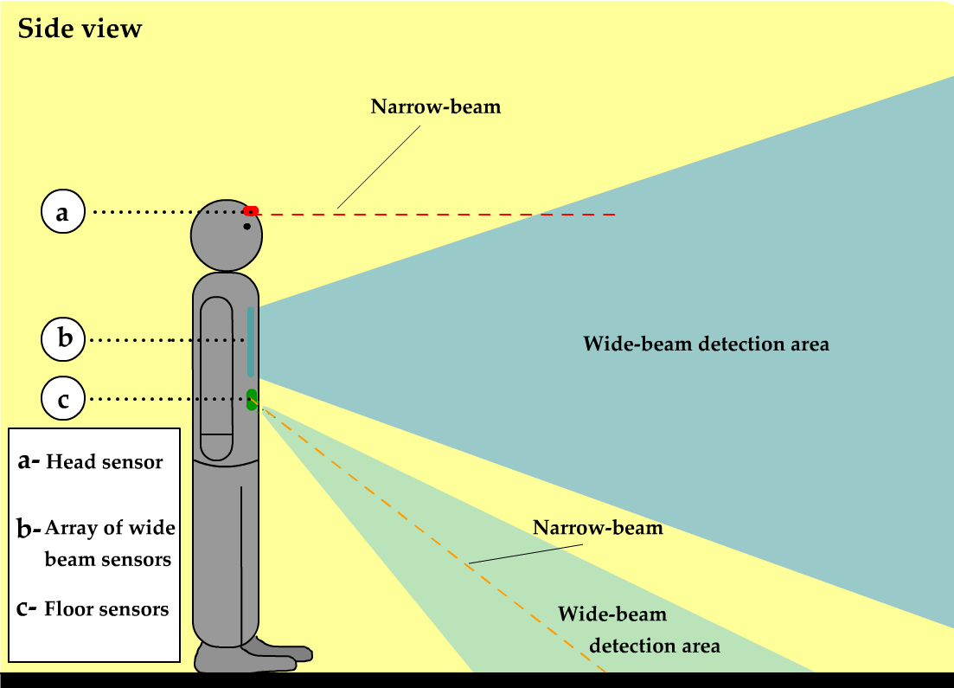
Figure 2 – Visual Aid side view.
The set of sensors is distributed in three modules. The head module consists of a narrow-beam sensor (represented as a dashed red line) mounted in the head of the user. The purpose of this module is to provide the user with accurate information regarding an objects position, size and distance.
The second module is the array of six wide-beam sensors. The use of wide-beam sensors enables the system to detect objects in a larger area. In order to give more detailed information on an object’s spatial location the sensors are arranged such that portions of their beams overlap with each other. The sensor matrix is aligned to give a wider range in the vertical orientation than the horizontal.
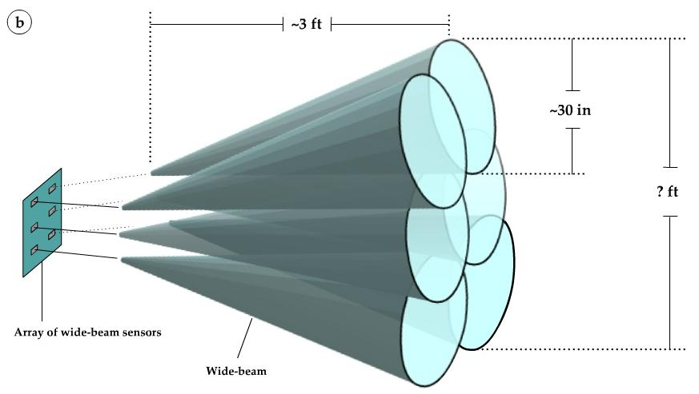
Figure 3 – Wide-beam sensors array.
The third module detects objects and steps up or down at the ground level. This module consists of a wide-beam sensor and a narrow-beam sensor. The wide-beam sensor detects objects and obstructions on the ground. The narrow-beam sensor detects uneven surfaces such as steps and stairs. This sensor will be positioned as shown in Figure 4 with an angle θ. This angle is adjustable to fit user needs. On flat surfaces, the sensor will detect a distance x + z. When a step is encountered, the distance read by the sensor will be diminished to x. In order to avoid “false” detection of steps due to the movement of the user’s body while walking, a digital filter is used.
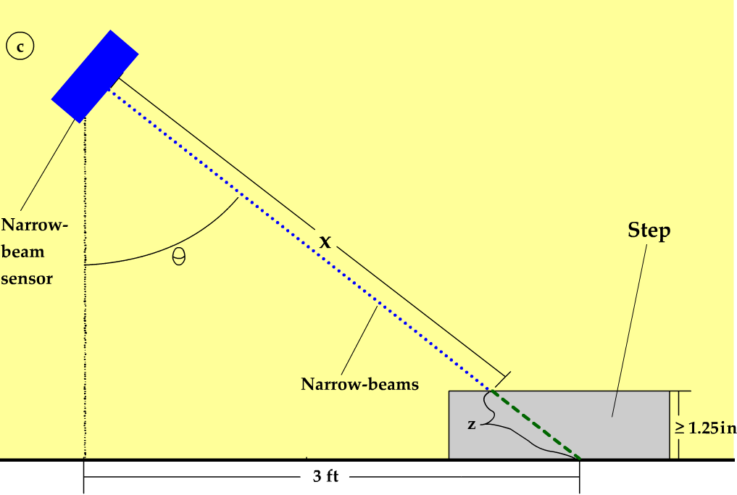
Figure 4 – Narrow-beam sensor.
The second major component of the system consists of 2 motors located in the front area of the user (see Figure 5), and 12 vibrating motors configured in a 3x3 matrix on the back of the user (see Figure 6). The head unit motor allows the user to scan for objects by moving their head; the motor will generate higher intensity for closer objects and lower intensity for farther objects. The narrow-beam motor is used to provide feedback about an uneven surface detected by the narrow beam sensor shown in Figure 4. The 3x3 matrix shown in Figure 6 is mounted on the users back provides feedback according to objects detected in front of the users. For example if an object is detected in the lower right corner, then the lower right motor will vibrate. The matrix motors also vary their intensity according to the distance of objects detected.

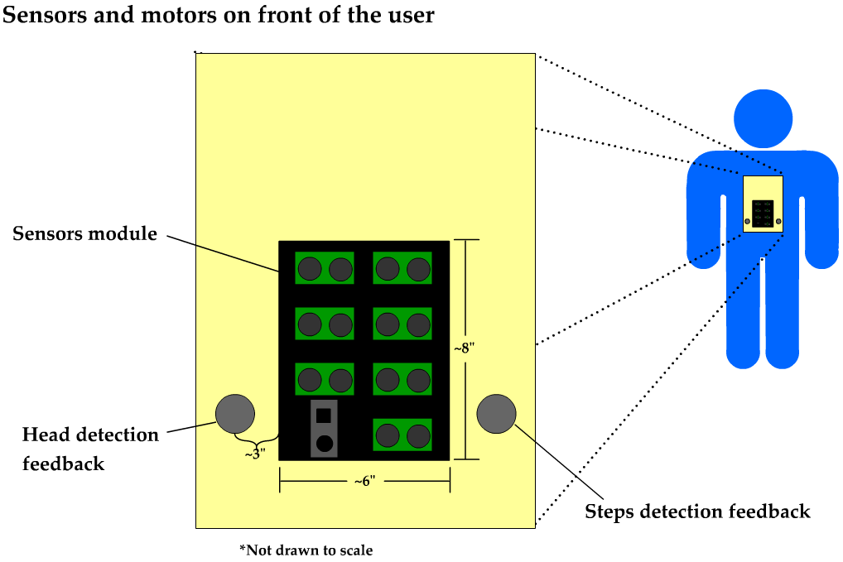
Figure 5 – Sensors and Front Motors

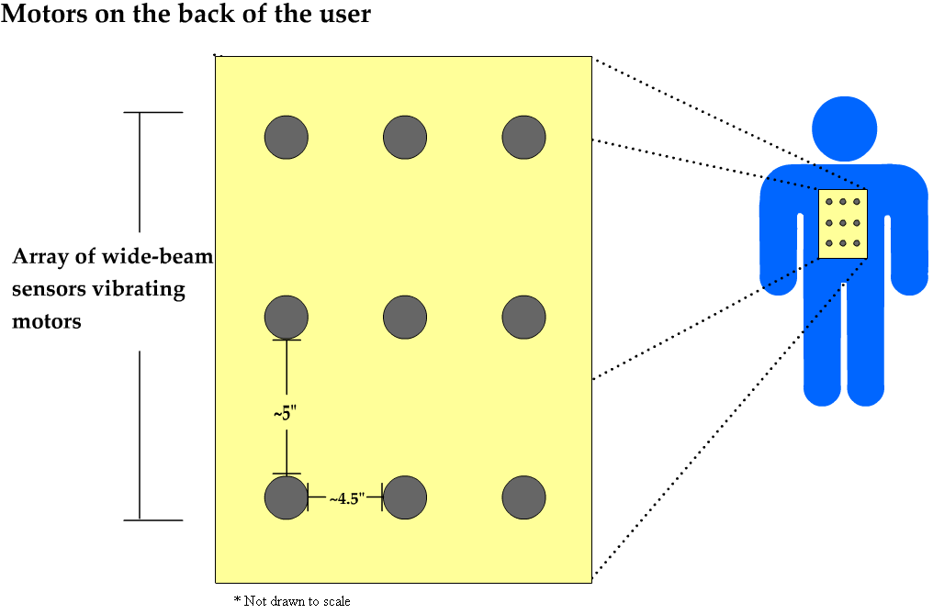
Figure 6 – The motors matrix.
The array of motors is mounted on the user with a vest. The array of sensors is located on the user’s chest and the motor matrix are located on the user’s back. The last physical component is the processing unit. This consists of the microcontroller unit which will read the inputs from all the sensors and will provide corresponding outputs to the user by controlling the vibrating motors.
  - The Functional Decomposition
The following sections outline the decomposition of level 0 diagram into a level 1 diagram with the design rationale included to provide some justification for the decisions made.
Level 0
The level 0 description of the Visual Aide describes the overall input, output, and behavior expected of the device.
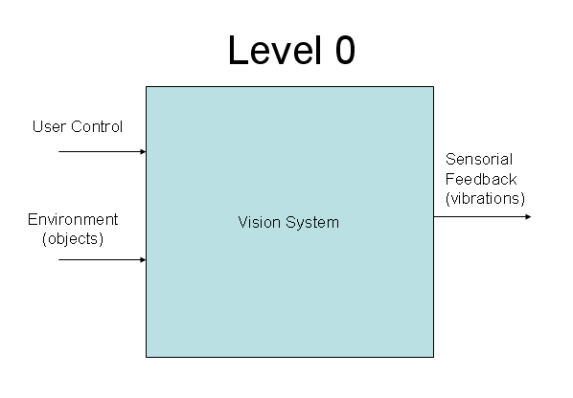
Figure 7 – Level 0.
The rationale for our level 0 design was to keep the system easy to control by a non-technical user. Too many buttons would confuse the user. The system will take environmental data of the surroundings (objects) as input and provide vibration feedback as output to the user. The only control is an on/off switch with everything else automated. The object is to provide the user with care-free operation.

Module | Vision System
Inputs | - User control: on/off  - Environment (objects): objects at least 1 in. wide and 2 in. high found in a 2 ft. wide area in front of the user, including steps.
Outputs | - Sensorial feedback (vibrations): a 3x3 matrix of vibrating motors, plus three additional vibrating motors.
Functionality | Alerts the user intuitively by means of vibrating motors as to what area and distance in front of the user object(s) is(are) and/or if there is a step. Detected objects are at least 1 in. wide and 2 in. high at a distance of at least 3 ft. from the user and as far as 7 ft. in an area 2 ft. wide. Variations of height (steps, rocks) of at least ±1.25 in. are detected at a distance of at least 3 ft. away from the user.
Level 1
The level 1 diagram reveals what is inside the level 0 box shown in Figure 7.
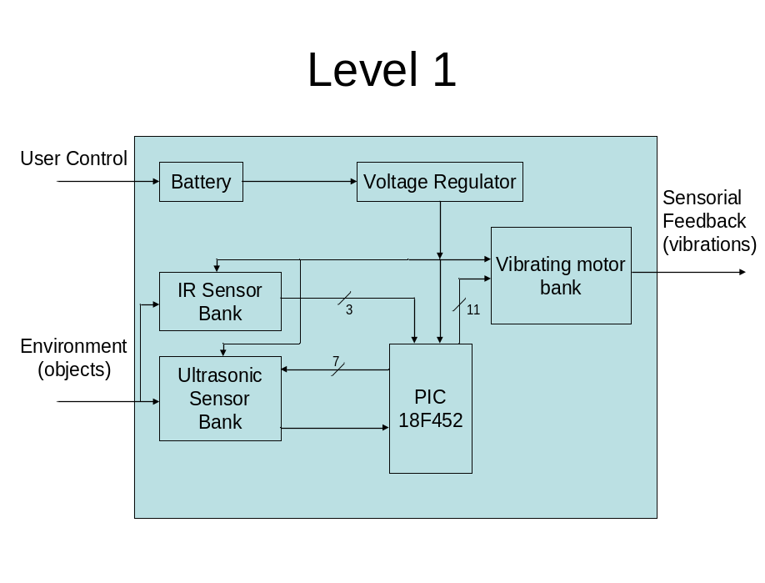
Figure 8 – Level 1 system design.
There are four main components in this part of our system design: the IR sensor bank, ultrasonic sensor bank, PIC18F452, and vibrating motor bank. Also, there are modules for supplying power to the components such as a voltage regulator.
The reason for breaking the design into these four main components is because each one provides a separate and distinct functionality towards the overall operation of the system. The IR Sensor Bank is responsible for detecting changes in elevation of the surface (steps, curbs, ledges) and also to identify objects targeted by they user’s head. The Ultrasonic Sensor Bank is responsible for detecting objects directly in front of the user and also indicating the object’s general location. The PIC18F452 is the control unit of the entire system. It will read data from the sensor banks, process the data, and provide feedback control via the vibrating motor bank. Finally, the vibrating motor bank, which is mounted on the back of the user, provides sensorial feedback to the user in the form of vibrations of varying intensity based on the proximity of the object and relative to the location of the object.
Module | Battery
Inputs | - User control: on/off
Outputs | - 9.6V DC
Functionality | Provide power to all electronics in the system.

Module | Voltage Regulator
Inputs | - 9.6V DC
Outputs | - 5V DC with up to 1A of current.
Functionality | Convert the battery’s 9.6V DC to 5V DC.

Module | IR Sensor Bank
Inputs | - 5V DC for power.  - Environment (objects): objects at head level and steps.
Outputs | - V₀-V₂: voltages ranging from 0.55V DC to 2.8V DC
Functionality | One sensor to detect objects at head level and another sensor angled to detect uneven surfaces.

Module | Ultrasonic Sensor Bank
Inputs | - 5V DC for power.  - Environment (objects): objects at least 1in wide and 2in high found in a 2ft wide area in front of the user.  - D₀-D₇: forwarded 5V DC 10µs control signal from PIC to selected sensor.
Outputs | - U₀-U₇: 0-5V DC pulse signal from 100µs to 18ms corresponding to selected sensor.
Functionality | Detects objects on the floor and in front of the user (under head level), and gives feedback regarding location and distance to object.

Module | Vibrating Motor Bank
Inputs | - 5V DC for power.  - M₀-M₁₁: PWM signals from 0-5V DC
Outputs | - Sensorial feedback (vibrations): sustained or pulsed vibrations with varied intensities.
Functionality | Converts the processed sensor information into feedback for the user.

Module | PIC 18F452
Inputs | - 5V DC for power.  - R₀-R₂: analog voltage feedback from 0.55Vto 2.8V  - U_{X}: 0-5V DC pulse signal from 100µs to 18ms.
Outputs | - S₀-S₂: digital select lines  - U_{C}: 5V DC 10µs pulse  - M₀-M₁₁: PWM signals with ? period and ?% duty cycle
Functionality | Gather data from ultrasonic and IR sensors, then convert it to PWM signals that drive the vibrating motors.
The first decision for the design was which method was best to detect objects. The following table outlines some of the advantages and disadvantages of a few methods.
Table 5 – Sensor selection decision.
Method | Advantages | Disadvantages
Ultrasonic sensor | Wide range  Inexpensive | Less accurate
IR sensor | Accurate  Inexpensive | Limited scope and range
Lasers | Accurate  Long distance detection | Expensive  Limited scope
Radar | Infinite range  Near perfect accuracy | Very expensive  Large and heavy  Expert knowledge required
Ultrasonic sensors were capable of detecting the area which we required (Range: 1” – 10’, with area of detection growing wider as distance increases). Infrared sensors were chosen because they have a relatively narrow beam which can be used to easily pinpoint the location of an object and also to conduct precise measurements to changes in elevation.
The main disadvantages to laser and radar technology were high costs and bulkiness. Also, no group member is familiar with the technology and large amounts of time to learn would be required. Laser technology is useful in detecting small objects at far distances, but we found that the large range of the lasers was unnecessary and the price of this technology is too high.
The next decision falls in the category of feedback to the user. The following table outlines of the advantages and disadvantages of two methods.
Table 6 – User feedback selection.
Method | Advantages | Disadvantages
Vibration | Quiet operation  Inexpensive | May take time for user to get used to this type of sensorial feedback
Audible | Unlimited capability | Interferes with a blind user’s vital hearing ability
The two alternatives to choose from involving feedback to the user were either through vibrations or audible sounds. After some interviews and extensive research of the visually-impaired, we learned that audible feedback would interfere with their vital sense of hearing. Most blind people are trained to enhance their hearing capability to navigate naturally as they walk so they typically avoid using devices that produce audible feedback. We chose to use the vibration method due to its quiet operation, although this method will likely require some getting used to as people are not used to having things producing this type of sensorial feedback on their body.
Finally, we needed to choose a method to control the other 3 components of the design. We chose the PIC18F452 because it provides subsystems that are very useful for our design such as multiple timer modules, and an ADC subsystem. Also, our familiarity with this device encouraged us to use it for our main control. The PIC also provides many I/O ports, plenty of internal flash memory, and is an inexpensive device.
  - High Level Software Description
The development of the software system exhibits the same modularity as the hardware design shown in Figure 8. Figure 9 shows the overall behavior of the system as a state diagram, listing out the sequence of operations that are performed by the MCU.

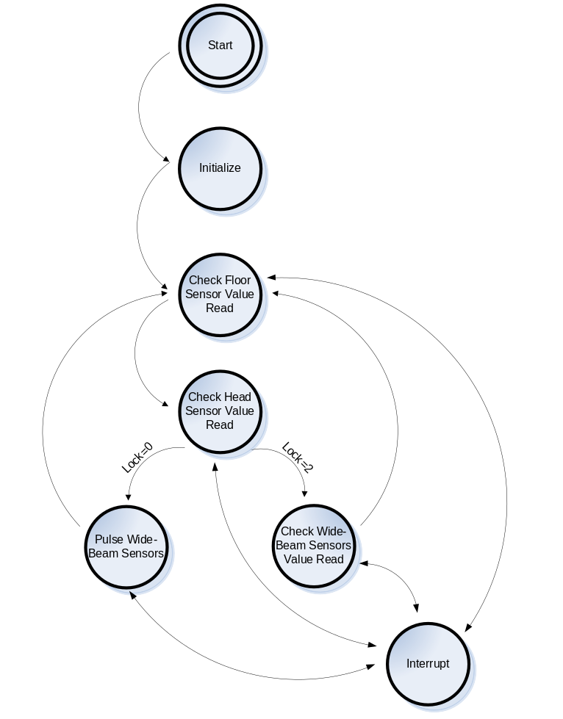
Figure 9 – Main state diagram for software.
In the list that follows, each of the states in Figure 9 is described in more details regarding its functionality.
- Start - This is a dummy state to represent the system when it is turned on. It will transition to Initialize Hardware state.
- Initialize - This is a function that runs at the beginning of the program (upon power-up of the system) to initialize the different hardware and modules used.
- Check Floor Sensor Value Read - The values read from the floor unit, specifically the narrow-beam sensor, are used to determine whether an uneven surface has been detected or not. If the surface is uneven, activate the corresponding motor.
- Check Head Sensor Value Read - The values read from the head unit are used to determine and set intensity that the motor corresponding to this unit should operate.
- Pulse Wide-Beam Sensors - This calls a function to pulse the ultrasonic sensors.
- Check Wide-Beam Sensors Value Read - The values from the ultrasonic sensors are used to determine where objects are and to activate the corresponding motors.
- Interrupt - This is a state to represent the various interrupt that can occur during the program. The only state where the interrupts are deactivated is in the Check Wide-Beam Sensors Value Read state. They have been deactivated due to sensitivity in the program to determine the pattern in which motors should be vibrating.

- Design Verification and Testing
The design testing is presented in the order that the tests were performed, from unit to acceptance tests.
  - Unit Testing
The performance of the IR sensor was critical to the success of the system as it would be observing the floor and informing the user of any upcoming steps. We had to test the sensor to see if it could distinguish the height bob of a walker from the drop off of a set of steps.
Table 7—IR sensor test.
Test Name: IR Sensor Test |  |  |  |  | Test Number: 101
Test Description: Verify that the IR sensor is correctly reading distance without unnecessary noise.
Test Information
Name of Tester: Luis |  | Date: 3/18/06 |  |  |  | Time: 2:00PM
# | Procedure | Pass | Fail | N/A |  | Comments
1 | Mount the IR Sensor and hold it vertically at waist level. | x
2 | Start Recording data while walking along a flat, obstacle-free path. | x
3 | Analyze that data to ensure that minimal noise is created from the up and down movement of walking. | x |  |  |  | Used Luis, Carl, and a rolling cart.
4 | Repeat test with stairs along the walking path. | x
5 | Analyze the values to ensure that they differ enough from data along the flat surface. | x |  |  |  | See data on next page for plots with different filters used.

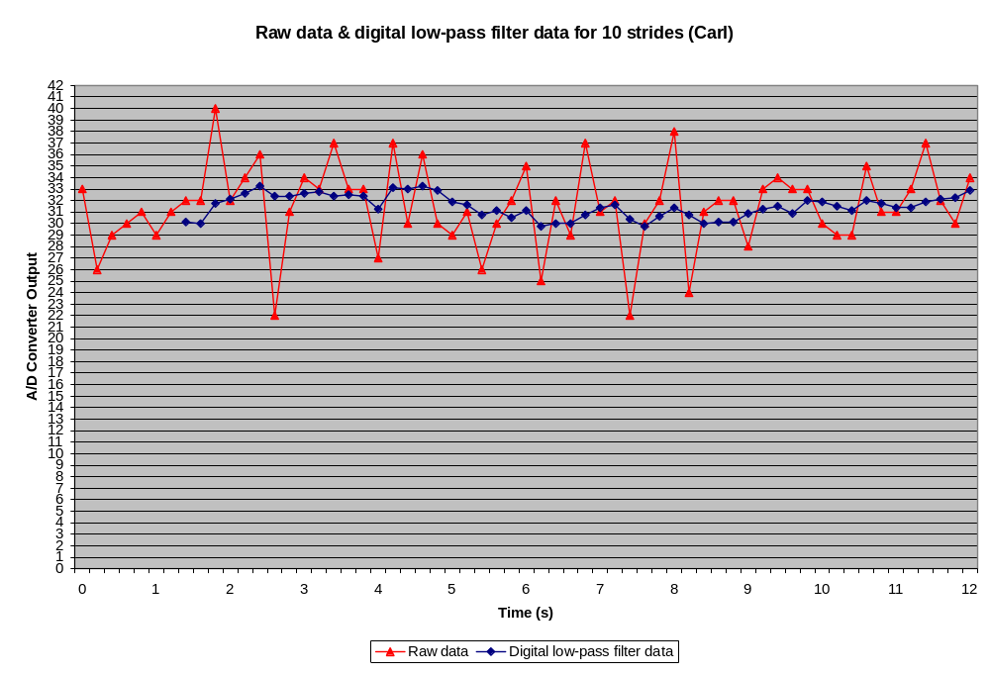
Figure 10 – ADC samples from the narrow beam sensor, raw and filtered.
The graph above shows the effects of using a digital low-pass filter on the readings from an IR sensor mounted at stomach-level on a walking person. The person walked on an even surface in a laboratory environment to gather the data samples. In comparison with the data obtained from the cart, the raw data has more noise, yet the low-pass filter manages to stabilize the value considerably.
    - Integration Testing
This integration test checks that individual ultrasonic sensors could trigger individual motors. This is critical to insuring that the system gives proper feedback to the user about their environment.
Table 8 – Integration testing
Test Name: Ultrasonic Sensor/Motor Test |  |  |  |  | Test Number: 200
Test Description:
Test Information
Name of Tester: Freddy and Ryan |  | Date: 3/25/06 |  |  |  | Time: 1:00PM
# | Procedure | Pass | Fail | N/A |  | Comments
1 | The tester should be wearing the visual aid system with the ultrasonic sensors and vibrating motors properly installed. | x
2 | Have someone place and object in the path of each individual sensor. | x
3 | Verify that the user is able to identify which position on the vibrating motor bank is being activated. Also, ensure the correct motor is being activated. | x
4 | Repeat step (3) for each ultrasonic sensor combination in order to activate each vibrating motor separately. | x
5 | Next, repeat the same procedure but activate multiple ultrasonic sensors and vibrating motors simultaneously and ensure that the unit is functioning properly. | x |  |  |  | See conclusions below.
This testing was performed many times and helped us to determine the proper adjustments/angles of the sensors. Performing these tests also gave us insight on what to set the sensor thresholds at in the software.
    - Acceptance Testing
One of the main engineering requirements is The system will detect objects that are at least 1in wide and 2in high at a distance of at least 3 ft from the user and as far as 7 ft in an area 2 ft wide, and provide sensory feedback. Also, the system should detect street signs and posts. In order to insure that this requirement was met, the following acceptance test was constructed.
Table 9 – Surface test.
Test Name: Object Detection Test |  |  |  |  | Test Number: 305
Test Description: Verify that the system can detect objects that are at least 1in wide and 2in high at a distance of at least 3 ft from the user and as far as 7 ft in an area 2 ft wide, and provide sensory feedback. Also, the system should detect street signs and posts
Test Information
Name of Tester: Freddy and Ryan |  | Date: 3/18/06 |  |  |  | Time: 12:30PM
# | Procedure | Pass | Fail | N/A |  | Comments
1 | On a flat level surface first mark a spot which is where the system will take readings from. | x
2 | Next, mark out a rectangular box on the floor, starting 3 feet from the testing position. The box should be centered with the testing spot and be 2 feet wide and 4 feet long. This box is used as reference for placing objects. (See comments) | X |  |  |  | 3’  2’  4’  X
3 | Place a small object which is approximately 1” wide and 2” high across the front line (Left Corner, Right Corner and Middle). Verify that the object is detected at each position and the appropriate motors are activated. | X |  |  |  | x x x
4 | Now, repeat step (3) but place the object across the back line. | X |  |  |  | x x x
5 | Again, repeat step (3) but place the object across the center of the box. | x |  |  |  | x x x
6 | Record all results and repeat test with objects of different sizes (poles, chairs, etc…) to ensure proper detection. | x |  |  |  | To verify this test we set up an obstacle course with objects which the user had to navigate through. See video for results of this test.

  - Requirements Verification
Tests were constructed and run for each of the engineering requirements. These are enumerated in the following table.
Table 10 – Requirements verification reference.
Engineering Requirement | Test Verification
The system’s total weight will not exceed 5 lbs. | Showed that weight did not exceed 5 lbs.  Test: Weight Test  Test #: 300
The system will have a single control to turn it on/off | Showed that ON/OFF switch works properly.(Sometimes needs switched twice)  Test: On/Off Switch Test  Test #: 301
The system will operate on full charge for at least 3 hours | Showed that the system will operate for at least 3 hours under normal conditions.  Test: Full Charge Operation Time  Test #: 302
The system should not exceed $600 | Showed that the total expenses to construct the system did not exceed $600 budget.  Test: Budget Test  Test #: 303
Uneven surfaces (steps, rocks) of at least ±1.25in high are detected at a distance of at least 3 ft away from the user | Showed that the system can properly detect uneven surfaces.  Test: Uneven Surface Test  Test #: 304
The system will detect objects that are at least 1in wide and 2in high at a distance of at least 3 ft from the user and as far as 7 ft in an area 2 ft wide, and provide sensory feedback. Also, the system should detect street signs and posts. | Showed that the system can properly detect objects of a minimum size in within the boundaries of the test area.  Test: Object Detection Test  Test #: 305
The system should not produce noise exceeding 40db | Showed that system noise is < 40db and is not distracting during quiet conversation.  Test: Sound Level Test  Test #: 306
The system is built with components that can operate in temperatures ranging from 0˚F to 120˚F | Showed that all components of system will operate properly with the temperature range.  Test: Operating Environment Temperature  Test #: 307
The system components is enclosed to be water-resistant | Components are not sealed in our prototype. Could be made water-resistant and tested.  Test: Water Resistant Test  Test #: 308
The system will refresh its output according to sensor readings 5 times per second | Showed that the system will refresh its output at least 5 times per second.  Test: Refreshing System Output Test  Test #: 309
- Summary and Conclusions
Overall, the project was completed successfully and all the critical requirements were met. We had the chance to meet with a visually impaired student and have him test the system. We were content with the satisfaction he demonstrated towards the system. Considering this system is at the prototype level, we are happy with the level of functionality the system was able to reach.
It was a challenge, but we were able to have the ultrasonic sensors and IR sensors work together without having to increase the complexity level of the system. This is important because the functions of both sensors are critical; the ultrasonic sensors perform the bulk of the detection work, and one of the IR sensors is used to detect steps.
While the system works well, there are some possible improvements to note:
- Place the motors on the front in a more sensitive area
- Make the system adaptable (turn off motors after long periods of time)
- Design a better vest more suited for everyday use
- Use a faster crystal or microcontroller to improve refresh rate
- Replace the IR sensors with more reliable and consistent sensors
- Put the circuitry in a PCB to reduce space and weight
- Fine-tune object detection with the ultrasonic sensors
The experience of working as a design team has taught us valuable lessons. We learned the importance of communicating as a team, and understanding the abilities and limitations of each member in order to maximize the team’s performance. Also, we realized how much of a difference a good planning can make; having a good design from the previous semester made it a lot easier to jump into work at the beginning of the term.
On a more technical level, we learned how much the use of analog and digital filters can help in cleaning signal noise. This played a major role in having the system operate correctly.
Finally, meeting with a blind person made us realize how important and useful it is to obtain feedback from the expected users of the system.
- References
[1] American Foundation for the Blind, “Blindness Statistics,” February 2006, http://www.afb.org.
[2] The Seeing Eye Inc, “About Us,” February 2006, http://www.seeingeye.org/AboutUs.asp.
[3] Nurion-Raycal, “LaserCane N-2000, Electronic Travel Aids,” February 2006, http://nurion.net/LC.html.
[4] GDP Research, “The Miniguide, an ultrasonic mobility aid, electronic travel aid (ETA),” February 2006, http://www.gdp-research.com.au/minig_1.htm.
[5] Robotron Group, “Robotron Sensory Tools - C2 Talking Compass,” February 2006, http://www.sensorytools.com/c2.htm.
[6] D. His Yen (yen@noogenesis.com), “Currently Available Electronic Travel Aids,” September 2005, http://www.noogenesis.com/eta/current.html.
[7] F. Miyara (fmiyara@fceia.unr.edu.ar), “Sound Levels,” February 2006, http://www.eie.fceia.unr.edu.ar/~acustica/comite/soundlev.htm.
[8] Division of Educational Programs, Argonne National Laboratory, “Cell Phone and Reaction Time,” September 2002, http://www.newton.dep.anl.gov/askasci/gen01/gen01264.htm.
[9] Hong Z. Tan. “Haptic Interfaces”. February 8, 2006. http://dynamo.ecn.purdue.edu/~hongtan/

